1 General 2
1.1 Business Process Flow 2
1.2 Data Flow 3
2 Foundation Data 4
3 Sales 4
4 Sales Admin 4
5 Production Planning 5
6 Paper Machine Production 5
6.1 Jumbo reel operation 5
6.2 Winder operation 6
6.3 Wrapping line operation 7
6.4 Rework 7
6.5 Reject / Pulper 8
7 Converting Operation 8
7.1 Request Roll for converting 8
7.2 Converting Line 9
7.3 Return roll to Warehouse 9
8 Warehouse Operation 9
8.1 Receive from production 10
8.2 Return to production 10
8.3 Create Load Plan 11
8.4 Loading 11
8.5 Ship 11
8.6 Inventory 12
8.7 Receive at other warehouse 12
8.8 Return from customer 12
9 Quality / Technical 12
10 Financial 13
10.1 Product costing 13
10.2 Invoicing 13
11 Recommendation 13

Meilun TM1 Business Process (Draft)

General
This write up is for better understanding of Chenming Meilun Project and some recommendation on the improvement. CM has not decided which ERP system for Meilun Project.

Business Process Flow
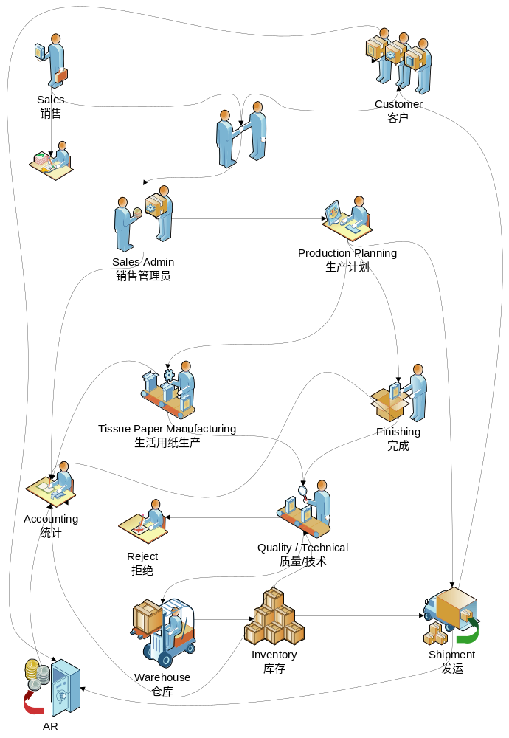

Data Flow
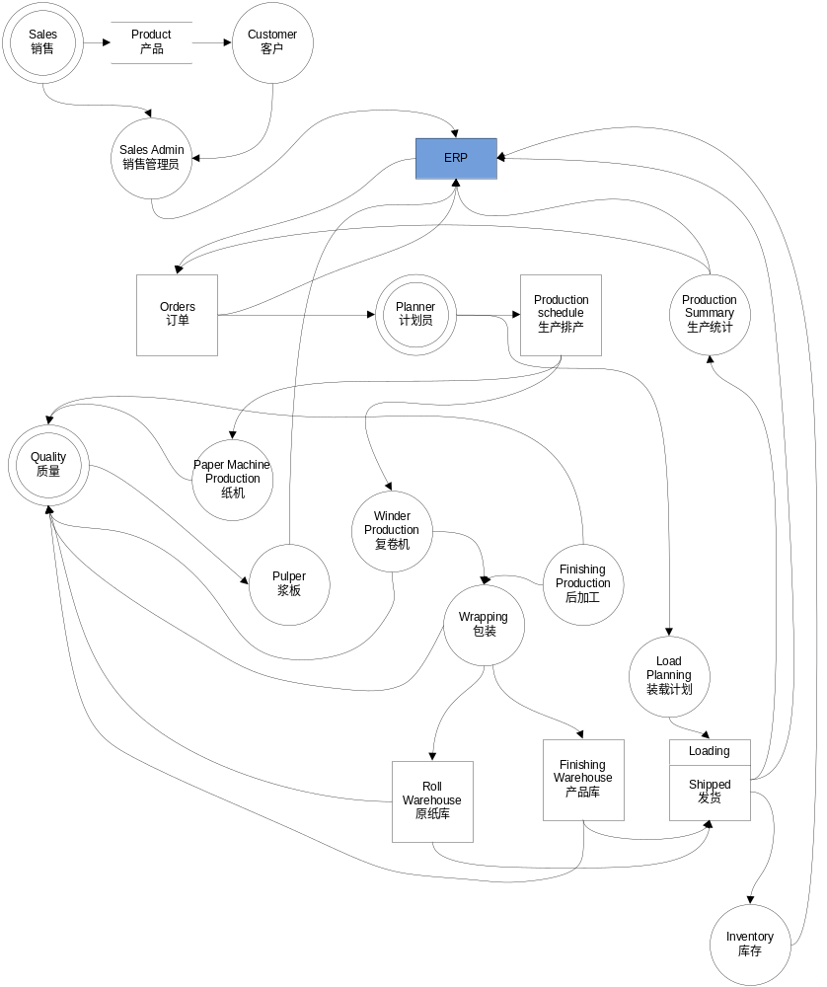

Foundation Data
Foundation data are the basic information required in CPM. During this process CM have to consider the naming convention for future expansion.

- Machine Data
- Product Data
- Article Data
- Customer / Consignee, this code is maintained in ERP.
- QMS Property code and template
- Others in excel template

Sales
Sales team distributed in several regions within China / Overseas. They are the front team which is facing the customer. In order to provide the fast delivery to the end customer, CM is setting up an external warehouse to be located near to the customer. In this strategy, tissue mill need to keep safety level of the common stock (CM own brand). CM may consider keeping safety level of OEM product as well, this will based on the contract.

Sales pack or SKU is maintained as the small units.

Most of the order delivery leads time within 7 days.

Information :
Customer (Domestic / Exports) / OEM Customer

Decision :
CM Sales strategy

Result :
Orders / Contract
Next process -> Sales Admin (4)

Sales Admin
During the Workshop discussion; CM strategy is to have centralize sales admin for Tissue Product at the Group Level.

Order entry should be in ERP. CPM does not keep the unit price of the customer orders.

Information :
- Orders / Contracts from sales team
- Customer credit limit

Decision :
- CM strategy (Consolidate the orders).
- Coordinate with the production planning to take the orders from the stock or produce it at the production line.
- Credit limit check with Finance

Result :
- Input Orders / Contract in to the systems
- Next process → Production Planning (5)

Production Planning
Production planning team is located at the Group Level.

Information :
Orders / Contracts

Decision :
- Stock allocation for the Orders which is ship from stock with the coordination with the warehouse department.
- Plan the replenishment orders or make to stock
- Trim the product
- Plan the delivery with coordination with Sales Team and Logistic/Warehouse team

Result :
- Production Scheduling for Paper Machine, Winders and converting line.
- Trim pattern for Winders and Converting line production.
- Delivery plan for warehouse operation
- Next process → Paper Machine Production (6), Converting Production (7) and Warehouse (8)

Paper Machine Production
Paper Machine production includes Jumbo reel, winder, wrapping and pulper operation.

Jumbo reel operation
There will be one PC terminal included laser printer and barcode printer to be installed near the dry end operator station or Paper machine control room

Information :
- Production planner creates the schedule (RUN) as the basic for paper machine to produce the product.
- Online Quality from QCS by jumbo reel ID
- Machine shutdown / break signal from MCS
- Time based data from DCS

Decision :
- Operator need to register all the jumbo and weight the jumbo. He need to select the spool id , product and check the correct information at the jumbo reel registration screen before he save the information.
- If there is the break or shutdown signal from MCS, he needs to assign the reasons and remarks.
- Jumbo reel ID need to be printed out and attached to the sample (slab paper)

Result :
- New jumbo ID / label created
- New Roll ID / Core Tag Label if the roll is automatically cut into two on the paper machine
- Quality confirmation from Technical / QC for the next production step.
- Reports ; machine log, production summary, break/shut down
- Next process → Winder operation (6.2), Wrapping line operation (6.3).

Winder operation
Winder operator is going to cut the jumbo reel based on the Run/Pattern from production planning.

There will be one PC terminal included handheld scanner and barcode printer to be installed near the Winder operator station

Information :
- Jumbo reel from PM which has been approved by QC
- Run/Pattern from production planning

Decision :
- Select the correct Run/Pattern to produce
- Mounted the jumbo reel by scanning the jumbo reel ID. He can mounted up to 3 jumbo reel in one onput. This is depending on the run/pattern.
- Register the new roll id when roll set turn-up
- Classified the roll (A, B, R, H or X)
- If the roll need to be bundle; bundle it manually and update the system.
- Assign the roll destination to Warehouse, Loading or Converting
- Print the core tag ID and stick it to the roll

Result :
- New Roll ID created with the status floor.
- Report; station log, production summary.
- Next process → Wrapping line operation (6.3), Rework (6.4), Pulper (6.5)

Wrapping line operation
Operator need to make sure the roll is having the ROLL ID. Please check with the winder operator if the roll does not have the roll id.
CM is going to design the format of shipping label (quality certificate label) in A5 size.

There will be one PC terminal included handheld scanner and barcode printer to be installed near the Wrapping line operator station

Information :
Roll with the roll ID

Decision :
- Scan the roll id and input the weight manually in CPM operator screen
- Compare the actual weight and calculated weight on CPM operator screen
- Print the shipping label (quality certificate label) and wrap the roll base on the order requirement

Result :
- Roll ID with status wrapped.
- Wrapped Roll with shipping label (quality certificate label) and destination.
- Report; station log, production summary.
- Next process → Converting production (7), Warehouse operation (8)

Rework
QC will make the decision on the roll/pallet which may need to rework or pulper

Information :
- Roll ID
- Pallet ID

Decision :
- Rework
- Reclassified

Result :
- Next process → Reject / Pulper (6.5), Wrapping line (6.3)

Reject / Pulper
Operator will pulper the rejected product.

There will be one PC terminal included handheld scanner to be installed near the pulper station. If the load is not high, CM may consider sharing this terminal with others (eg. Winder or Wrapping line).

Information :
Bad quality of the product which has been confirmed by QC

Decision :
Consume the Roll/Pallet by scanning the barcode ID at CPM Pulper station

Result :
Report; station log, production summary

Converting Operation
CM produces core toilet tissue, non core toilet tissue, napkin, handkerchief and facial tissue.

The converting operation can be divided into 4 main locations. In this case, CM needs 4 PC terminals included handheld scanner and barcode printer to be installed near the station.

CM needs to design the pallet id format in A5 size.

Request Roll for converting
Converting production line need to request roll for production usage.

Information :
- Production schedule for converting line
- Product, Width, Diameter

Decision :
- Physically move the roll from warehouse to the converting line
- Perform the roll movement in CPM

Result :
- Roll status changed
- Report; station log, production summary
- Next process →converting line (7.2)

Converting Line
Information :
- Run schedule from production planning
- Roll ID
- Converting material (wrapper, box, pallet etc)

Decision :
- Consumed the roll
- Register new pallet id (converting product) when the pallet is full.

Result :
- Print the new pallet id in A5, stick it on the box and manually wrapped the pallet.
- Report; station log, production summary
- Next process → receive from production (8.1)

Return roll to Warehouse
Converting production line is able to return the rolls to warehouse.

Information :
- Roll ID

Decission :
- Scan the roll id and process the roll movement in the CPM
- Physically move the rolls to the location defined in the CPM

Result :
- Next process → receive from production (8.1)

Warehouse Operation
CM has two warehouse at the mill, roll warehouse and converting (pallet) warehouse. For the efficiency on the warehouse operation, ABB strongly recommended to install WLAN, and store the converting product on pallet by defining the bin location.

Production planner will create delivery instruction for the orders.

Warehouse department will create the loading plan based on the destination, consignee and transports method. Load type “Ship” is for normal shipment directly to the customer. There could be the possibility to move the product (rolls / pallets) from one warehouse to the other warehouse. In this case, warehouse operation need to create load plan with “Transit” method.

Loading operator will load the product (roll / pallet) based on the load plan. It’s possible to have the barcode printed on the Load Plan.

Receive from production
Roll
Operator will pick up the roll which has been wrapped and move it to the warehouse. The supervisor is able to predefine the bin location to accept the product in the warehouse.

Converting/Pallet
Every pallet of the converting product will have the palled id. The pallet id was printed manually as soon as pallet is full. It’s recommended to wrap the pallet manually. Operator will pick up the pallet which has been wrapped and move it to the warehouse. The supervisor is able to predefine the bin location to accept the product in the warehouse.

Information :
- Roll id or Pallet id

Decision :
- Scan the roll id / pallet id by using wireless terminal and select the predefined bin location.
- Put the physical roll id/pallet id to the bin location which has been selected.

Result :
- Inventory (8.6) increase
- Report; station log, production summary

Return to production
If product is damage in the warehouse, supervisor need to make a decision to return it to production. He need to seek approval from QC.

Information ;
- Roll ID or Pallet ID which is damaged

Decision :
- Move the physical roll / pallet to the production line
- Perform the transaction in CPM for returning the goods to production

Result :
- Goods return to production
- Report; station log, production summary
- Next process → Quality (9), Rework (6.4)

Create Load Plan
Information :
- Delivery Instruction from production planning
- Transportation readiness
- Product availability

Decision :
- Assign the operator to perform the loading

Result :
- Load plan report for loading operator
- Next process → Loading (8.4)

Loading
Information :
- Load plan report

Decision :
- Scan the load plan to performe the loading start
- Load the product base on the load plan by using Wireless Terminal
- Cross check the scanned ID (roll / pallet). If there is an error, please check the physical product
- When finish the loading, please mark the load completed

Result :
- Packing list
- Delivery notes
- Next process → Shipped (8.5)

Ship
Operator need to mark the Load to “Shipped” when the goods leave the mill.

Information :
- Load number

Decision :
- Mark the selected load number as “Shipped”

Result :
- Report; station log
- Next process → Invoicing (10.2)

Inventory
Movement of the product in and out from the warehouse will impact the inventory. All the roll id / pallet id need to be scanned if it’s moved within different warehouse bin or return to production or consumed or rejected or shipped.

Receive at other warehouse
This process is required when CM is transferring the product from one warehouse to another warehouse.

Information :
- Load number

Decision :
- Input the load number and perform receive the load. Unload the rolls / pallet to the bin location
- Physically move the product to the bin location as defined in the system

Result :
- Inventory(8.6) increased at the receiving warehouse

Return from customer
Customer are able to return full load or partial load of the product delivery.

Information :
- Load number
- Roll ID / Pallet ID if partial return

Decision :
- Perform the load return by input the load number
- Unload the complete roll/pallet for the full return load number
- Unload the selected roll/pallet for the load number
- Assign the warehouse bin for these rolls/pallets

Result :
- Product received at warehouse
- Inventory increase at the warehouse
- Financial statement need to handle in ERP

Quality / Technical
Technical department need to define the product standard (quality specification). All the naming convention need to be agreed among sales, production and warehouse team.

CM needs to create the SOP.

Financial
CM has to decide ERP system to be used in Meilun Project

Product costing
Product costing can be variance between different mill. CM need to provide detail costing method. CPM can only calculate the product cost based on standard cost. Is it by product, grade, grammage or by export / domestic?

Invoicing
Invoicing basically is done inside ERP. CPM can only provide the basic information for invoicing.

During the loading process, every truck/container/orders are having the load. In the load contains the detail quantity of rolls / pallets and customer information.

Information :
- Detail load quantity from CPM
- Sales price from ERP

Decision :
- Consolidate the load by customer
- Calculate the total invoice amount

Result :
- Invoiced customer
- Account receivable

Recommendation
ABB recommended:
- CM has to decide on ERP system to use.
- WLAN to be installed at the warehouse (roll / converting) and loading.
- All pallets should have the pallet ID and manually wrapped.
- All rolls should have core tag ID.
- CM has to design the warehouse bin location for easy storage and loading bay allocation. Warehouse management skill set is required.
- Storage and shipment for the converting goods is by pallets or rolls.
- CM has to design the core tag label and shipping label (quality certificate label) for roll and pallet in the pre-printed format.
- CM has to provide the based template for product costing calculation.
- CM needs to design the template for delivery note, packing list.

